Lab 4: KNN and Evaluation Metrics
Learning Objectives
- Supervised Learning Algorithms
- K-Nearest Neighbor
- Evaluation Metrics
- Difference Between ANN and Classical ML Algorithms

- K-Nearest Neighbor
The k-nearest neighbors (KNN) algorithm is a simple, easy-to-implement supervised machine learning algorithm that can be used to solve both classification and regression problems. The K-nearest neighbor algorithm assumes that similar things exist in close proximity to each other. It uses feature similarity for predicting values of new data points. The algorithm helps grouping similar data points together according to their proximity. The main goal of the algorithm is to determine how likely it is for a data point to be a part of the specific group. However, it is more widely used in classification problems in the industry.
In other words, similar things are near to each other (and this is true in most cases). But before implementing k-NN, one must know the optimal value of k (number of nearest neighbors for prediction) to start.
Value of k is selected such that it is neither too small nor too big.
- As we decrease the value of K to 1, our predictions become less stable (Outlier - ???)
- Inversely, as we increase the value of K, our predictions become more stable due to majority voting/averaging, and thus, more likely to make more accurate predictions (up to a certain point).
In classification problems, we usually make K an odd number to have a tiebreaker.

- Accuracy
Accuracy is the ratio of correct predictions to the total number of predictions. It is used to find the portion of correctly classified values. It tells us how often our classifier is right. It is one of the simplest measures of a model. We must aim for high accuracy for our model. If a model has high accuracy, we can infer that the model makes correct predictions most of the time

Without Sklearn:
accuracy = (TP + TN)/(TP + FP + TN + FN)
print(accuracy*100)

With Sklearn:
from sklearn.metrics import accuracy_score
print(accuracy_score(labels , predictions)*100)

- Recall

Without Sklearn:
recall = (TP)/(TP+FN)
print(recall*100)

With Sklearn:
from sklearn.metrics import recall_score
print(recall_score(labels,predictions))

- Precision

Without Sklearn:
precision = TP/(TP+FP)
print(precision)

With Sklearn:
from sklearn.metrics import precision_score
print(precision_score(labels,predictions)*100)

- F1 Score
This is a weighted average of the true positive rate (recall) and precision. F1 score depends on both the Recall and Precision, it is harmonic mean of both the values. It is useful when you need to take both precision and recall into account. It is maximum when Precision is equal to Recall.

Without Sklearn:
f1 = 2*(precision * recall)/(precision + recall)
print(f1)

With Sklearn:
from sklearn.metrics import f1_score
print(f1_score(labels, predictions))

Lab Tasks
- Use the Iris dataset from sklearn.datasets. Load it into a Pandas DataFrame and display the first few rows.
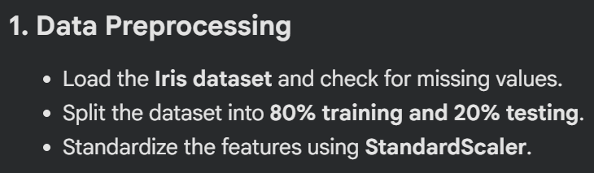
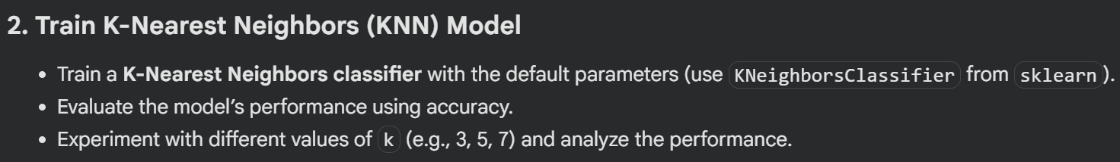

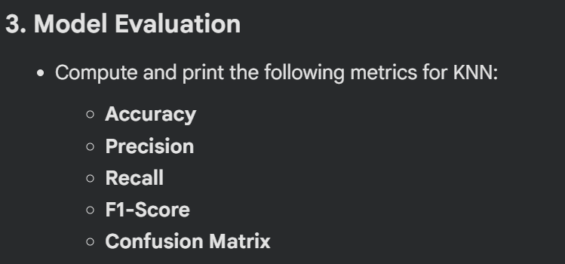

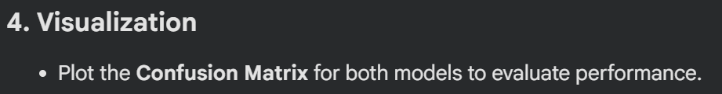

- Go through the attached Colab Notebook.
- Load the MNIST dataset and normalize the pixel values to the range 0-1.
- Reshape the 28x28 images into a 1D vector of size 784 for ANN compatibility.
- Build a simple ANN model with:
  - An input layer with 784 neurons.
  - One hidden layer with 128 neurons and ReLU activation.
  - An output layer with 10 neurons and softmax activation.
- Compile the model using the Adam optimizer, sparse categorical crossentropy as the loss function, and accuracy as a metric.
- Train the model on the training data for 10 epochs with a batch size of 32.
- Evaluate the model on the test dataset and report the test accuracy.
- Use the trained model to predict the classes for 5 random test samples and display the images with their predicted and actual labels.
- Calculate precision, recall, and F1-score for each class using the test dataset and include these metrics in the evaluation report.
- Save the trained model to a file and reload it for predictions on new data.

Lab # 4 Marks distribution

 | ER1 | ER5 | ER8
Task | 3 points | 3 points | 4 points

Lab # 4 Rubric Evaluation Guideline:
# | Qualities & Criteria | 0 < Poor <= 1 | 1 < Satisfactory <= 2 | 2 < Excellent <=3
ER1 | Task Completion | Minimal or no program functionality was achieved. | Some tasks were completed, but the program has errors or incomplete functionalities. | All tasks were completed, and the program runs without errors.
# | Qualities & Criteria | 0 < Poor <= 1 | 1 < Satisfactory <= 2 | 2 < Excellent <=3
ER5 | Analysis of Results | No attempt to analyze or interpret the results | Some analysis of the results is attempted, but explanations may be unclear or incomplete. | Results are correctly analyzed and compared to expectations, with clear explanations.
# | Qualities & Criteria | 0 < Poor <= 1 | 1.5 < Satisfactory <= 2.5 | 2.5 < Excellent <= 4
ER8 | Question & Answer | Answers some questions but not confidently or based on lab task knowledge. | Answers most questions confidently and based on lab task knowledge. | Answers all questions confidently and demonstrates a deep understanding of the given lab task.

